Expanded form of a Number
In expanded form of a number, the number is shown according to the place values of its digits.
This is shown here:
In 2385, the place values of the digits are given below:
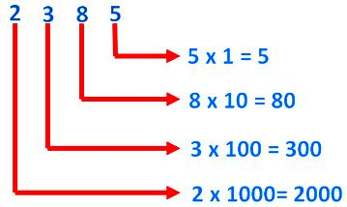
Hence, 2385 = 2000 + 300 + 80 + 5
Thus, 2000 + 300 + 80 + 5 is the expanded form of 2385.

1. Find the expanded form of 453169.
Solution:
Place values of digits 453169
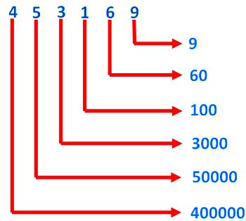
So, 453169 = 400000 + 50000 + 3000 + 100 + 60 + 9
2. Write the number in figures and then in words for the following expanded form:
(i) 80000 + 8000 + 500 + 50 + 7
Solution:
80000 + 8000 + 500 + 50 + 7
= 88557 (in figures)
Eighty eight thousand five hundred fifty seven (in words)
(ii) 100000 + 30000 + 2000 + 10 + 6
Solution:
100000 + 30000 + 2000 + 10 + 6 = 132016 (in figures)
One hundred thirty two thousand sixteen (in words)
We can write the expanded form of numbers in different ways.

